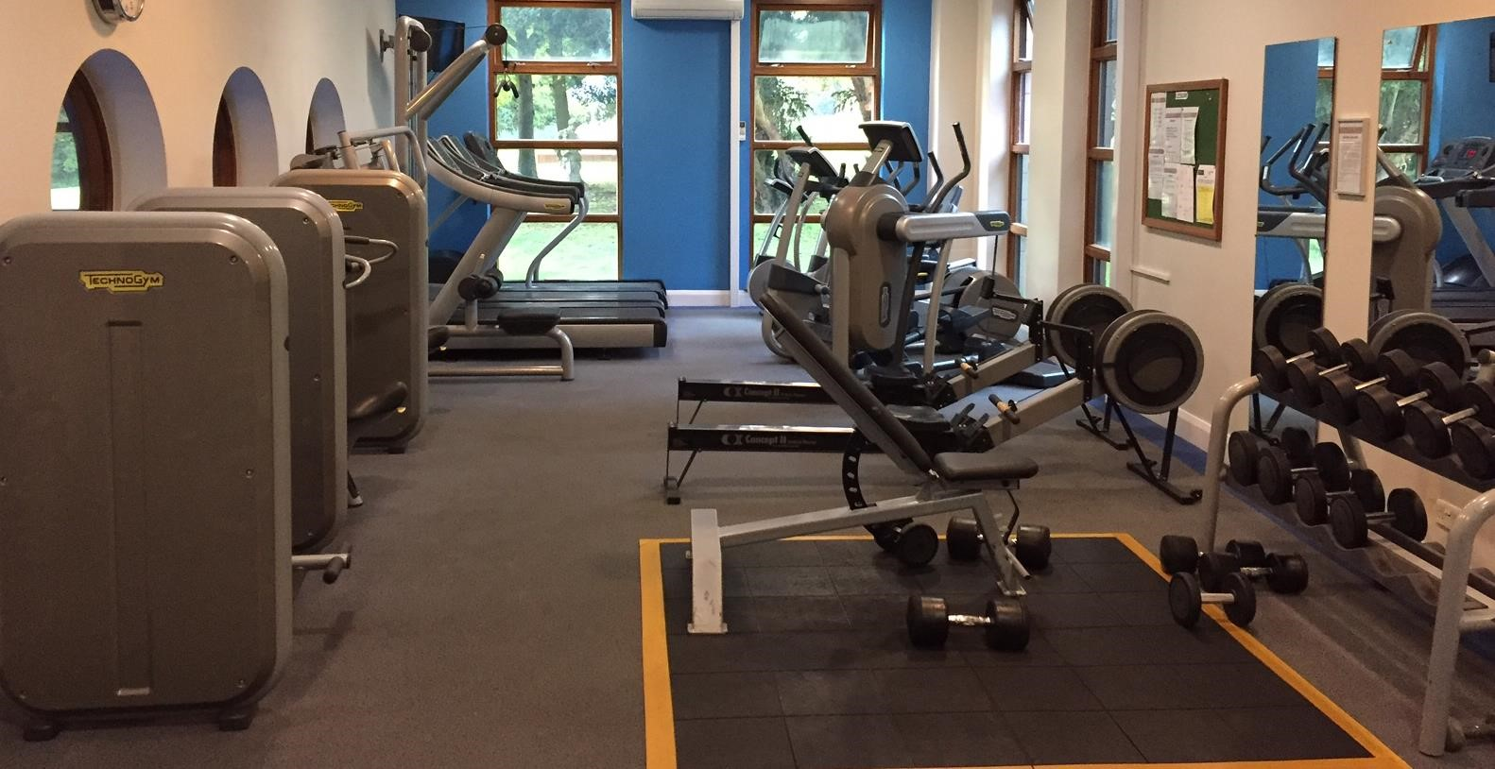

Leisure Membership Pack

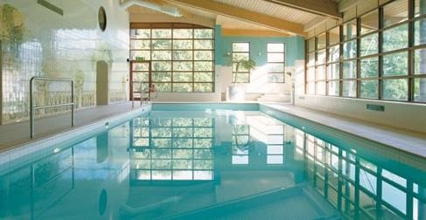

Private Leisure Membership

Whether it’s to improve fitness, increase stamina, relieve stress, build muscle or just meet new friends, Denham Grove not only has excellent facilities, but our emphasis on customer service guarantees a more intimate and friendly atmosphere to reach those goals. Our new partnerships with Chiltern Swim & Bucks Fitness offer our members fantastic opportunities at discounted prices.

Our Facilities include | Our Membership includes
# Heated Indoor 18m Swimming Pool  # Sauna Room  # Air-conditioned Fitness  Suite with 16-pieces of high-spec Cardio & Strength equipment plus free-weights and dumbbells  # Changing and Shower Facilities  # Seasonal Tennis Courts  # Access to Got2swim and Bodyfit  Coaching and fitness programs  # Opening times are Monday – Sunday  6.30am – 9:30pm (last admittance 9:15pm) | # 20% off all food and beverages within the hotel  # £79 B&B Rate per Standard room per night (Thursday to Monday ; booked only within a 7 day window )  # FREE use of our Venue WiFi  # FREE Parking  # No Joiners Fee  # 10% discount on all Got2swim and Bodyfit # FREE Gym induction (mandatory) and access to qualified personal trainer for advice.

Our Pricing * as from 01/05/2024
 | Annual | Monthly
Single | £550 | £55 / £660
Couple | £950 | £90 / £1080
Children (5-15)  DAY PASS : £ 11.50 | £200 | £20 / £240

Joining Requirements
Upon joining you will be asked to complete this document including full health questionnaire and provide 2 passport size photographs. If joining on an annual payment basis you will be required to pay the full membership cost at this time. If joining on a monthly direct debit basis you will be required to complete a direct debit mandate, but also submit the first two months payment by cash or credit/debit card. A membership card will be provided to you based on your membership option and you will be required to attend a mandatory 1-hour gym induction within 1 month of joining our club.

Membership Options
Memberships can be discussed at appointments and show rounds which can be arranged by telephone on 01895 833338 or by email reception@denhamgrove.com
Children Policy
Children aged 16 and above must join as full members. Children aged under 16 can be added to single or couple memberships but cannot use the gym. They may only use the pool under the supervision of an adult member. Children aged 5 or under may use the pool with adult members free of charge.


Since April 2010, got2swim have run private swimming lessons for all age groups at Denham Grove. They have specific times where they have the pool exclusively, during these times the pool, spa & sauna are unavailable for use by members although the changing rooms and gym are fully open. Intensive coaching is also held during all half-term weeks and some other school holiday dates, usually from 9.00-11.30am.
Occasionally and outside these times tuition occurs but the pool is not exclusive to got2swim.
Please see timings below:
Monday 12.30pm – 2pm 1 Lane
3.45pm – 6.15pm - WHOLE POOL

Tuesday 12.30pm – 2.30pm 1 Lane
3.45pm – 6.15pm - WHOLE POOL

Wednesday 3.45pm – 6.15pm - WHOLE POOL

Thursday 1pm – 2.30pm 1 Lane
3.45pm – 6.15pm – WHOLE POOL

Friday 9:30am - 12pm 1 Lane
3.45pm – 6.15pm – WHOLE POOL

Saturday 9am - 1pm WHOLE POOL

Sunday NO LESSONS

Swimming lessons are run by ASA qualified instructors, under the leadership of Bruce Snodgrass, previously Head Coach of the Chalfont Otters. Bruce is a former South African National Team Member, National Record holder and 4-time All American who successfully coached Marianne Kriel to her bronze medal in the 100 backstroke at the 1996 Atlanta Games. Patron of Chiltern Swim is Jonty Skinner, World Class Technical Advisor to British Swimming and a former Director of USA Swimming & coach to 18 Olympic Gold Medalists.
Got2Swim offers our leisure members a 10% discount on the cost of swimming lessons and can be contacted on bruce@got2swim.co.uk



We have secured the services of Jack Waldren of Body Fit to provide a number of leisure services at Denham. Jack offers private personal training, completes gym inductions and provides other associated lessons & classes, such as early morning Boot Camps. Jack does not require exclusive use of the gym so from a membership perspective there is no conflict. Jack comes with a wealth of experience and is driven to help people achieve their health and wellbeing goals. For further information and any advanced bookings or enquiries, please do not hesitate to contact Jack.

His contact details can be found on his website : - http://www.jwbodyfit.co.uk

Private Leisure Membership Terms and Conditions

Members of the Denham Grove Leisure Club are bound as a condition of their membership to comply with the regulations set out below.
These have been drawn up by Denham Grove with a view to ensuring that the Leisure Club facilities are properly and safely used and that all members are able to take full advantage of them without interfering with the enjoyment of others.
PRICING We reserve the right to change prices on an annual basis. 30 days notice will be given of any change. Members who have not completed their 12 month contract will not be expected to pay the updated price until their current 12 month contract expires.
MEMBER ACCESS Entry to the leisure facilities is permitted only at the reception desk; all members must show their card at each visit and sign the register before entering and when departing the leisure club. Members applying for a replacement card will be subject to an administration fee of £10.00.
CHILDREN Children aged 16 and above must join as full members. Children aged under 16 can be added to single or couple memberships but cannot use the gym and may only use the pool under the supervision of an adult member. Children aged 5 or under may use the pool with adult members free of charge
LOCKERS For security reasons and for the benefit of other members, all lockers must be vacated by the end of each visit. All lockers are checked and emptied at least once a month. Denham Grove do not accept liability for loss, theft or damage to any personal belongings.
CHANGING ROOMS Children under the age of 8 years must be accompanied by an adult at all times. Any children above the age of 8 years a change it the appropriate sex changing rooms. Mobile phones are not to be used in the changing rooms. Children are not to change in public areas such as corridors.
TOWELS Towels are available for you to collect and use at reception. Towels must be left in the bins provided in the changing rooms. Any towels taken offsite will be considered as theft and members could face criminal charges and expulsion.
ANIMALS Animals, with the exception of Guide Dogs are not permitted anywhere in the Leisure Club at any time.
SMOKING Smoking is not permitted by UK Law anywhere.
CLOTHING Members are requested to dress in a manner appropriate to the sporting activity they are engaged in. Members are also reminded of the corporate nature of the hotel mid-week and we request appropriate dress within the lounge and bar facilities.
CANCELLATION Fees and subscriptions are paid in advance and will not be refunded unless cancelled within 14 days of joining.
If you’re paying on a Direct Debit basis and you wish to cancel you will still need to pay the month you cancelled in. Memberships will automatically cease on the expiry date unless membership is renewed. In the case of having to temporarily suspend membership due to long term injury, illness or pregnancy, written acceptance must be received from the venue prior to suspension. To cancel your annual membership a notice of 1 month is required in writing to Denham Grove and members are obliged to continue paying their subscription until the agreed cancellation date.
F&B DISCOUNTS Membership includes a food & beverage discount which you may apply to a maximum of 10 guests. Members are not entitled to utilize these discounts for any other group activities of more than 10 people, such as Restaurant meals. Equally social / function activities are not included, such as Christmas Parties. Membership card must be shown at time of purchase to receive these discounts.
GENERAL/TERMINATION OF MEMBERSHIP
- Members must agree to the rules.
- The proprietors reserve the right to make changes to the rules upon reasonable notice.
- The proprietors reserve the right to terminate membership for serious breach of the rules, or conduct which, in the proprietors reasonable opinion, is damaging to the character or interest of the club or offensive to other members of staff.
- In the event of termination by Denham Grove, under the above regulation, no monies will be refunded to the member.
- Members must advise staff of any disability such as blindness, deafness, heart conditions, epilepsy and/or any other conditions prior to using the facilities so that they may avoid accidents, injuries or misadventure to themselves and others.
- Whilst using the facilities all members accept responsibility for their state of health and physical conditions.
- Absolute discretion is used by Denham Grove, to reject any application or renewal of membership without ascribing any reason for doing so.
- Entry to the leisure facilities is permitted only at the main reception desk; all members must sign the register before entering.
- The proprietors may at any time withdraw all or part of the club facilities for any period or periods where it may be deemed necessary for repair, maintenance, alteration, safety reasons or for alternative/exclusive use.
- Please leave all bags and outdoor clothing in the lockers provided.
- Photography and the recording of images of any kind are only allowed with the written authorization of Denham Grove.
- Denham Grove reserves the right to alter/amend any of the prices/rules/regulations/opening or closing times in this document at any time.
- Denham Grove is manned at all times but our leisure facilities are not. Security Cameras are in use 24 hours a day. USE OF HEALTH AND FITNESS FACILITIES
- Appropriate clothing and footwear must be worn at all times.
- Drinks may only be taken into the fitness suite in a plastic container.
- In the interests of safety, no persons under the age of 16 are admitted to the gym.
- All equipment has been designed and tested to be safe with current use. It is the members responsibility to ensure they know how to use the equipment provided. Gym inductions are mandatory for all members.
- At peak times the club has the right to limit the use of the cardiovascular equipment to 15 minutes. USE OF THE LEISURE POOL AREA
- Appropriate swimming attire only is allowed in the pool area.
- Please shower on entering the pool area and especially before and after using the sauna, steam rooms and always shower immediately before using the Jacuzzi. Do not use shampoos or conditioners in the swimming pool shower area.
- For safe Jacuzzi bathing, limit visits to 15 minutes maximum.
- Please observe the notices displayed in the pool area.
- Children under the age of 16 years must be under strict supervision of their parents or guardians at all times.
- Emergency pull cord is in use in the sauna and in case of emergency a phone is provided in the pool area. Improper use of the emergency equipment may result in disciplinary action.

Private Leisure Membership

Application Form

Please complete the application form below and attach 2 passport-sized photographs per applicant.

MAIN MEMBER |  | PARTNER
Title |  | Title
Forenames |  | Forenames
Surname |  | Surname
Date of Birth |  | Date of Birth
Address  Post Code |  | Address  Post Code
Contact Details Home Tel.  Work Tel.  Mobile Tel.  Email Address |  | Contact Details Home Tel.  Work Tel.  Mobile Tel.  Email Address
Emergency  Contact Details  Contact Name  Relationship  Telephone No. |  | Emergency  Contact Details  Contact Name  Relationship  Telephone No.
OFFICE USE  Membership No. |  | OFFICE USE  Membership No.

MEMBERS DECLARATION

I warrant that the above information is correct and agree to abide by the terms and conditions of the club. These conditions are enclosed with this application form.

Main Member signature: _______________________ Partner signature: ____________________________

Date: ____________________ Date: ____________________

Private Leisure Membership

Basic Health and Safety Questionnaire
PLEASE COMPLETE THE FOLLOWING QUESTIONS AS ACCURATELY AS YOU CAN.

YOU MAY NOT USE THE GYMNASIUM IF YOU DO NOT PRESENTLY USE ONE ELSEWHERE OR HAVE NOT EXERCISED REGULARLY WITHIN THE LAST SIX MONTHS.

- Do you suffer from a heart condition,
high blood pressure or other associated problems? YES/NO

- Do you suffer from pains in your chest or become
breathless when exercising at low intensity? YES/NO

- Do you regularly suffer from headaches or feel
dizzy and faint? YES/NO

- Are you taking and medication or recuperating
from a recent illness or operation? YES/NO

- Do you suffer from diabetes, epilepsy
or asthma? YES/NO

- Are you pregnant or have you given birth in the
last six months? YES/NO

- Do you have any medical condition or injury
that may effect your ability to exercise? YES/NO

- Are you unaccustomed to exercise on
a general day-to-day basis? YES/NO

If you have answered yes to one or more of the above questions you may be refused use of the gymnasium. We would strongly recommend that you consult with your doctor before you begin any new exercise program. Denham Grove reserves the right to refuse membership on the grounds of health and safety. For more information please refer to our terms and conditions.

Please read and sign the declaration below if you intend to use the gymnasium.

I have answered all the questions to the best of my knowledge. I will exercise within my limit and at my own risk.

Name:

Signature: Date:

Private Leisure Membership

Basic Health and Safety Questionnaire

PLEASE COMPLETE THE FOLLOWING QUESTIONS AS ACCURATELY AS YOU CAN.

YOU MAY NOT USE THE GYMNASIUM IF YOU DO NOT PRESENTLY USE ONE ELSEWHERE OR HAVE NOT EXERCISED REGULARLY WITHIN THE LAST SIX MONTHS.

- Do you suffer from a heart condition,
high blood pressure or other associated problems? YES/NO

- Do you suffer from pains in your chest or become
breathless when exercising at low intensity? YES/NO

- Do you regularly suffer from headaches or feel
dizzy and faint? YES/NO

- Are you taking and medication or recuperating
from a recent illness or operation? YES/NO

- Do you suffer from diabetes, epilepsy
or asthma? YES/NO

- Are you pregnant or have you given birth in the
last six months? YES/NO

- Do you have any medical condition or injury
that may effect your ability to exercise? YES/NO

- Are you unaccustomed to exercise on
a general day-to-day basis? YES/NO

If you have answered yes to one or more of the above questions you may be refused use of the gymnasium. We would strongly recommend that you consult with your doctor before you begin any new exercise program. Denham Grove reserves the right to refuse membership on the grounds of health and safety. For more information please refer to our terms and conditions.

Please read and sign the declaration below if you intend to use the gymnasium.

I have answered all the questions to the best of my knowledge. I will exercise within my limit and at my own risk.

Name:

Signature: Date:

Confidential Health Profile

DATE. _________________________________________  NAME. _________________________________________  HOME ADDRESS. ________________________________  _______________________________________________  _______________________________________________  OCCUPATION. __________________________________  TEL NO. (home) _________________________________  (work) __________________________________  Date of Birth. ___________________________________  PERSONAL CONSENT FOR EXERCISE.  I declare that the information I have given is correct and that I know of no reason why I should not participate in exercise classes, or use the gymnasium. I undertake to use the gymnasium equipment and to exercise only in accordance with the instructions of the gymnasium equipment and/or staff. I acknowledge that any use of the equipment and participation in exercise classes is entirely at my own risk.  Signed:  Date: | Do you take any form of  exercise  YES / NO  Type:-  Frequency: | Are you currently receiving any treatment or medication from your doctor that would affect you during your participation of exercise or use of gymnasium equipment?  YES NO  Please specify.
Have you any muscle or joint injury which may affect your ability to exercise?
If Yes give details:-

Is there any medical problem which may affect your ability to exercise?

YES / NO YES / NO

High Blood Pressure
Diabetes
Arthritis/Rheumatism

Heart Trouble
Sciatica
Bronchitis Kidney Complaint
Epilepsy Hernia
Angina Other?

 | Any further information that may be relevant to this health profile. | Leisure Manager Sign Off.  Signed.  _____________________________  Date.

Confidential Health Profile

DATE. _________________________________________  NAME. _________________________________________  HOME ADDRESS. ________________________________  _______________________________________________  _______________________________________________  OCCUPATION. __________________________________  TEL NO. (home) _________________________________  (work) __________________________________  Date of Birth. ___________________________________  PERSONAL CONSENT FOR EXERCISE.  I declare that the information I have given is correct and that I know of no reason why I should not participate in exercise classes, or use the gymnasium. I undertake to use the gymnasium equipment and to exercise only in accordance with the instructions of the gymnasium equipment and/or staff. I acknowledge that any use of the equipment and participation in exercise classes is entirely at my own risk.  Signed:  Date: | Do you take any form of  exercise  YES / NO  Type:-  Frequency: | Are you currently receiving any treatment or medication from your doctor that would affect you during your participation of exercise or use of gymnasium equipment?  YES NO  Please specify.
Have you any muscle or joint injury which may affect your ability to exercise?
If Yes give details:-

Is there any medical problem which may affect your ability to exercise?

YES / NO YES / NO

High Blood Pressure
Diabetes
Arthritis/Rheumatism

Heart Trouble
Sciatica
Bronchitis Kidney Complaint
Epilepsy Hernia
Angina Other?

 | Any further information that may be relevant to this health profile. | Leisure Manager Sign Off.  Signed.  _____________________________  Date.

